

Living Weapon

# Setting:

The year is 1944 and the player takes command of a hidden British crew that has stolen a top-secret enemy tank. The Panzer X is a modular living weapon that can change its parts on a whim. The player must deliver the Panzer X by escaping the enemy country.

2d Sidescrolling Modular Tank Game

2020 People Pals | New Zealand

Table of Contents

Setting: 0

Colour Pallet: 2

Controls (Core): 2

Controls (Menus): 2

Inspirations: 2

Mechanics: 3

Armor Parts: 3

Hud: 4

Notes: 4

References 5

# Colour Pallet:

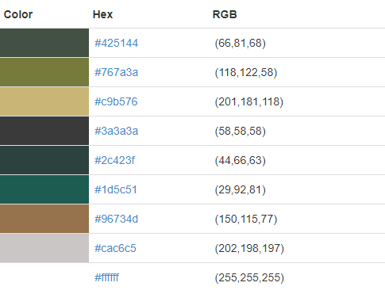

# Controls (Core):

* [A] Move Left
* [D] Move Right
* [W] Aim Up
* [S] Aim Down
* [Spacebar] Fire
* [unknown] Jump
* [M. L Click] Pick up
* [M. Hover] Display part details

# Controls (Menus):

* [M. L Click] Select item
* [M. R Click] Mini Menu of item
* [M. Drag] Move selected item

# Inspirations:

* Metal Slug ( Nazca Corporation, 1996)
* ShellShock Live (KChamp, 2013)
* Resident Evil 4 (Capcom, 2005)
* Crossout (Gaijin Games, 2020)
* Kingdom Hearts 1 (Square Enix, 2002)

# Mechanics:

* Random (Premade) enemies that drop part items.
* Goal: Get to the end of the map.
* Tetris inventory
* Weight based on parts

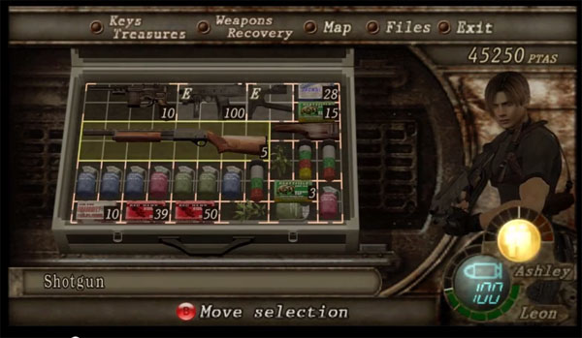

Figure - Tetris Inventory example (Capcom, 2005)

# Tank design:

Tracks

Core

Hull

Hull

Hull

Hull

Gun

Special

Tracks

## Armor Parts:

* Core
  + Upgradable
  + Increases build limit and weight limit
* Hull
  + Type
  + Health
  + Weight
  + Mix and match different hull sizes
* Track
  + Speed
  + Anti-Weight
* Gun
  + Size
  + Damage
  + Weight
  + Recoil?
* Special
  + Ability
  + Weight

# Enemy Types:

* Tanks
  + Aggressive AI
  + Defensive AI
* Human Turrets
* Tank Turrets
* Helicopters
* Mortar tanks/turrets (“snipers”)

# Game over conditions

When the core is hit/sustained enough damage the player/enemy is blown up. The core can be exposed when the hull is destroyed (the hull has its own health bar). Note that if a part is attached to a destroyed hull, it drops to the ground (able to be picked back up).

# Hud:

Stats

# Notes:

* Glow
* Drag and drop
* Scrapping for repair
* Inventory special parts

# References

Nazca Corporation. (1996, April 19). *Metal Slug*. Retrieved from Wikipedia: https://en.wikipedia.org/wiki/Metal_Slug

Capcom. (2005, January 11). *Resident Evil 4*. Retrieved from Wikipedia: https://en.wikipedia.org/wiki/Resident_Evil_4

Gaijin Games. (2020). *Cross Out: Craft, Ride, Destroy.* Retrieved from Cross Out: https://crossout.net/en/#/

KChamp. (2013). *ShellShock Live 2*. Retrieved from ShellShock Live 2: https://www.shellshocklive2.com/

Square Enix. (2002). *Kingdom Hearts*. Retrieved from Wikipedia: https://en.wikipedia.org/wiki/Kingdom_Hearts_(video_game)